**Drowsiness Detection and Alert System**

*Manish Mate1, Abhishek Sahu2, Atharva Kadam3, Rajat Tandulkar4, Arpita Agarwal5*

*1,2,3,4UG - Computer Engineering, Department of Computer Engineering, Pillai College of Engineering, New Panvel, Navi Mumbai, India.*

*5Associate Professor, Computer Engineering, Department of Computer Engineering, Pillai College of Engineering, New Panvel, Navi Mumbai, India*

***Emails:*** *manish20comp@student.mes.ac.in1, asahu20comp@student.mes.ac.in2,*

*agkadam20comp@student.mes.ac.in3, rtandulkar20comp@student.mes.ac.in4, arpitaagarwal@mes.ac.in5*

# *Abstract*

*Drowsiness detection is a solution for identifying signs of fatigue or sleepiness in individuals. One of the key features of our model is that it can detect drowsiness at night as well using Mobile cameras (infrared sensors). The system captures infrared images of the person's face and analyzes the physiological and behavioral cues related to drowsiness. Infrared sensors allow for drowsiness detection in low-light conditions, making it particularly useful for night-time scenarios such as night driving. The system can trigger alerts or interventions if drowsiness is detected, helping to prevent accidents or mistakes. We will be using libraries like OpenCV, TensorFlow, CNN, and VGG19 features in our model. By combining the accessibility of Android devices with the advanced capabilities of the Deep Learning algorithm, drowsiness detection using infrared sensors has the potential to greatly improve the safety and productivity of individuals in their daily lives.*

***Keywords:*** *Deep-Learning; OpenCV; TensorFlow; Transfer learning; VGG 1.*

## 1. Introduction

Drowsy driving poses a significant threat on roads worldwide, with countless accidents, injuries, and fatalities attributed to driver fatigue each year, as highlighted by the National Highway Traffic Safety Administration. In response, a crucial initiative has emerged: the development of a Drowsiness

Detection and Alert System. This innovative project aims to utilize advanced technology, including artificial intelligence and sensors, to detect signs of drowsiness in drivers and provide timely alerts, thereby preventing potential accidents [5]. By leveraging real-time monitoring and analysis, this system holds promise in enhancing road safety and minimizing the devastating impact of drowsy driving incidents, marking a pivotal step towards a safer future for all road users.Drowsy driving is a major problem on roads worldwide. Numerous collisions stem from drivers experiencing fatigue or lapses in attention while operating vehicles. As per research conducted by the National Highway Traffic Safety Administration (NHTSA), approximately

72,000 accidents, resulting in 44,000 injuries and 800 fatalities annually, are attributed to drowsy driving solely in the United States. This project aims to develop a Drowsiness Detection and Alert System that can detect drowsy driving behavior and alert the driver to prevent accidents [6]. **1.1. Fundamental**

The Drowsiness Detection and Alert System utilizes computer vision and Deep Learning principles. A mobile camera installed on the dashboard of a vehicle is utilized to observe the driver's facial expressions and movements. These visual inputs are then analyzed by a Convolutional Neural Network (CNN) to detect indicators of drowsiness, such as variations in eye openness. The CNN undergoes training using a dataset comprising images of drivers exhibiting both open and closed eyes to learn patterns associated with drowsiness. Upon identifying drowsiness, the system activates an alert mechanism, which may include audible alarms, vibrations, or flashing lights. Overall, this system is crucial for preventing accidents caused by drowsy driving by promptly detecting and alerting drivers to take a break [7].

### 1.2. Objective

Automatic reading aims to provide a consistent and unbiased evaluation of short answer scripts, ensuring that all scripts are assessed using the same criteria and standards, without human bias or subjectivity. Automated grading systems aim to save time and resources by automating the grading process, reducing the need for manual grading, and providing prompt feedback to students [8]. Automatic grading systems are designed to handle a large volume of short answer scripts efficiently, making them suitable for high-stakes assessments, large-scale exams, or assessments with a large number of students. Given an answer to a question from a selected set of questions, we aim to evaluate it and give a qualitative score. The subjective nature of an answer makes it difficult to grade it uniformly across many human graders [9]. In addition, human graders tend to unknowingly grade an answer with their own biases towards the subject matter presented. Manual grading has another major drawback, the time required to grade essays can be significantly high. **1.3. Scope**

The scope of the "Drowsiness Detection and Alert System" project is to design and implement a system that can detect drowsiness in individuals and provide alerts to prevent accidents caused by drowsy driving or operating heavy machinery. The system will utilize a blend of sensors and advanced learning methods to scrutinize the user's actions and recognize indications of drowsiness, including sluggish eye movements, yawning, and alterations in posture. Once drowsiness is detected, the system will alert the user in the form of an audible or visual warning, such as a beep or flashing light.The project strives to offer a dependable and userfriendly resolution to the issue of drowsy driving, aiming to prevent accidents resulting from driver fatigue.The system can be implemented in various settings, such as in personal vehicles, commercial trucks, and heavy machinery. The project seeks to investigate the possibilities of employing deep learning techniques and Android applications to create inventive solutions aimed at enhancing road safety and mitigating accidents [10]. **2. Literature Survey**

The "Drowsiness Detection and Alert System" project utilizes deep learning, transfer learning, and OpenCV to detect signs of drowsiness like slow eye movement and yawning. By providing timely alerts through audible or visual warnings, it aims to prevent accidents caused by drowsy driving, offering a reliable solution to enhance road safety and mitigate the risks of driver fatigue. Machine learning algorithms have been extensively used for drowsiness detection. Ayush Goel and Jainav Sharma proposed a model using machine learning, their approach used libraries like OpenCV, sciPy, and image magiCk to extract the features from the user.

## 2.1.Literature Review

* Ayush Goel, Jainav Sharma, Sumit Jindal, “Driver Drowsiness Detection System” (2023) [1]. Driving while intoxicated is a severe issue that may result in collisions, injuries, and fatalities. Machine learning algorithms might be trained to more precisely anticipate when a motorist is at risk of falling asleep by examining vast quantities of data on driving behavior. Features used by them include the frequency of rubbing eyes and difficulty in keeping the head up or eyes open.The libraries used by them include OpenCV, NumPy, and SciPy, to process data from sensors, Pillow, and ImageMagick.They also used NLP libraries like NLTK and spaCy for driver’s speech signs.The model concentrates on momentum as a possible simple method for documenting the transient state.
* Jaspreet Singh Bajaj,Dr. Naveen Kumar “System and Method for Driver Drowsiness

Detection Using Behavioral and SensorBasedPhysiological Measures”(2023)[2]. They have used data from the National Highway Traffic Safety Administration (NHTSA). Based on the assessment of the study, integrating non-intrusive behavioral measures with sensor-based physiological measurements results in better outcomes and circumvents certain challenges. A suggested hybrid model assists in detecting driver sleepiness under all circumstances. For investigating the transition from an alert to a drowsy state, the driver's facial features are captured using a camera as a behavioral indicator, while a GSR sensor is employed as a physiological gauge.

* Jagbeer Singh, Ritika Kanojia “Driver Drowsiness Detection System - An approach by Machine Learning Application” (2022) [3]. In this paper, the authors present a deep learning-based algorithm for driver fatigue detection, integrating facial and eye movement features trained on realworld driving data to achieve high accuracy. They also propose a driver identification system alongside the fatigue detection model.

Acknowledging the limitations of relying solely on eye states, they incorporate facial expressions to enhance detection accuracy. While deep learning offers improved performance over traditional methods, the authors recognize potential implementation challenges for widespread adoption. Nonetheless, their study sheds light on the efficacy of deep learning in fatigue detection and underscores the importance of continued research to enhance road safety. • Aslam Uddin, Saydul Akbar Mura “4D: A Real-Time Driver Drowsiness Detection Using

Deep Learning” (2023) [4] The proposal introduces a CNN (Convolutional Neural Network) framework designed to detect driver drowsiness in real-time by analyzing the condition of their eyes. The model achieved an accuracy of 97.4% on the MRL Eye dataset, outperforming other models. The model detects three levels of drowsiness - alert, drowsy, and very drowsy - based on eye closure and movement. The authors developed a real-time application using the trained model, which can process video input from a camera mounted on the dashboard of a car and alert the driver if they are detected to be drowsy. The study highlights using deep learning and machine learning for accurate drowsiness detection, potentially preventing accidents and saving lives on the road.

## 3. Implemented System/ Proposed System

### 3.1. Overview

A driver drowsiness detection system identifies driver fatigue, a significant factor in road accidents.

The system uses a combination of sensors, cameras, and algorithms to monitor driver behavior and movements and detect signs of drowsiness. Some of the common signs of drowsiness that the system can detect include eye closure duration, blinking frequency, and head-pose changes. This technology uses image-processing techniques to analyze video feeds from cameras to detect facial features, head posture, and eye movements [11]. The system then uses machine learning algorithms to learn the patterns of drowsiness based on the data collected from the sensors.Machine learning algorithms are trained on driver data to recognize signs of drowsiness like yawning, drooping eyelids, and impaired driving. Once the system detects signs of drowsiness, it alerts the driver in real-time through audio and visual alerts. The alert can take the form of an alarm, vibration, or message displayed on the dashboard. The driver can then take appropriate actions, such as taking a break, drinking coffee, or switching drivers. Driver drowsiness detection systems have several social applications, including improving road safety, healthcare, transportation, insurance, and government regulations [12]. This can help reduce the number of accidents caused by drowsy driving and save lives on the road. In summary, driver drowsiness detection systems are crucial technologies for preventing accidents due to driver fatigue and enhancing road safety.

**3.1.1. Existing System Architecture The Existing System works as follows: -**

● The EfficientNetB0 architecture is the backbone of a gated recurrent unit (GRU) recurrent neural network, combining CNN and RNN functionalities. This fusion allows for comprehensive analysis of sequential image data, particularly useful for real-time drowsiness detection in drivers [13].

* Here, the EfficientNetB0 architecture serves as the foundation for a gated recurrent unit (GRU) recurrent neural network, amalgamating CNN and RNN functionalities.
* The GRU network is tasked with processing a dataset comprising 600 facial images of the driver. Its objective is to meticulously analyze these images, seeking to discern subtle yet critical features that serve as indicators of drowsiness, especially focusing on the crucial moments preceding potential incidents [14].
* Transfer learning was utilized in the GRU module, integrating the EfficientNetB0 architecture in Figure 2.

|  |
| --- |
| **Figure 1 Existing System Architecture**    **3.1.2. Proposed System Architecture**    **Figure 2 Implemented System’s Model Training Workflow** |

* The GRU network processes 600 facial images of the driver, aiming to identify key features indicative of drowsiness within the final moments in Figure 1.
* The Training dataset was further subdivided into two classes Open Eye and Close Eye to train the model similarly test data contained the same work to test the model for prediction.
* CNN’s Transfer Learning methods VGG 19 model is used to train the model on a given dataset and with appropriate fine-tuning of hyperparameters is done to make the model work accurately and in a precise way.

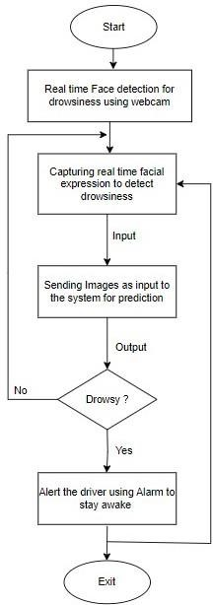

# Figure 3 Real-Time Drowsiness Detection

* The system operates by opening a mobile application where the system’s camera starts locating the ROI, that is, face, to detect drowsiness. ● It starts by capturing facial expressions to detect drowsiness [15].
* It sends the IReal-Time Input to the system for detection
* When the system identifies signs of drowsiness in the driver, it raises the threshold score and notifies the driver with an alarm to remain alert. If not, it will continue to be evaluated until drowsiness is detected in Figure 3.

## 3.2. Implementation Details

### 3.2.1. Methodology

The methodology employed in this study begins with the preprocessing of the MRL Eye Dataset, categorizing images into "Close Eyes" and "Open Eyes" for classification. Transfer learning is then utilized, leveraging the VGG19 pre-trained model, known for its robustness in image classification tasks. Custom layers are incorporated onto the pretrained model to customize it for the particular purpose of identifying closed and open eyes. Pretrained layers are frozen to retain learned features, and the model is compiled using appropriate optimization techniques and loss functions. Data augmentation methods are utilized to enhance the variety within the training dataset. The model is trained over multiple epochs, with real-time predictions integrated into the system for drowsiness and yawning detection using OpenCV and dlib libraries. Real-time visualization of drowsiness and yawning predictions provides immediate feedback to users, enhancing safety and awareness.

### 3.2.2. Algorithm name

* **Transfer Learning with VGG19:**

Transfer learning is applied using the VGG19 pretrained convolutional neural network (CNN). VGG19 is well-suited for image classification tasks due to its deep architecture and superior performance on large datasets like 'imagenet'. It provides a solid foundation for feature extraction, enabling effective adaptation to the drowsiness detection task.

* **Face and Eye Detection with OpenCV:** OpenCV and dlib libraries are employed for face and eye detection in real-time video streams. OpenCV offers robust computer vision functionalities, while dlib provides efficient facial landmark detection. This combination enables accurate localization of facial features, crucial for subsequent drowsiness and yawning detection.
* **Custom Neural Network Layers:**

Specialized neural network layers are appended onto the pre-existing VGG19 model to tailor it for the specific objective of detecting drowsiness. These layers include Global Average Pooling 2D (GAP) for spatial dimension reduction, Dense layers for capturing complex patterns, and Dropout layers for regularization. Together, they enhance the model's ability to discern features indicative of drowsiness from input eye images.

* **Yawning Detection using Lip Landmark Analysis:** Yawning detection is facilitated by analyzing the distance between upper and lower lip landmarks detected using dlib. By setting a predefined threshold for lip distance, yawning events can be accurately identified in real-time video frames. This approach provides an additional layer of drowsiness detection, complementing the eye-based detection system.

**3.2.3. Hardware and Software**

# Specifications

**Table 1 Hardware Details**

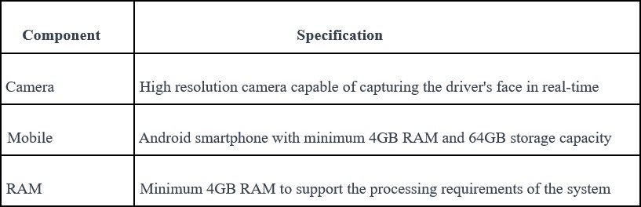

## Table 2 Software Details

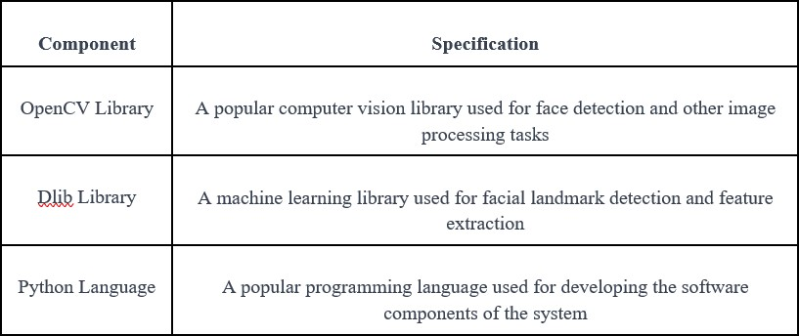

### 4. Result and Discussion

#### 4.1. Performance Evaluation Images

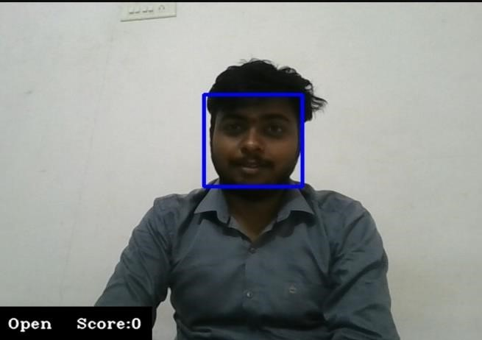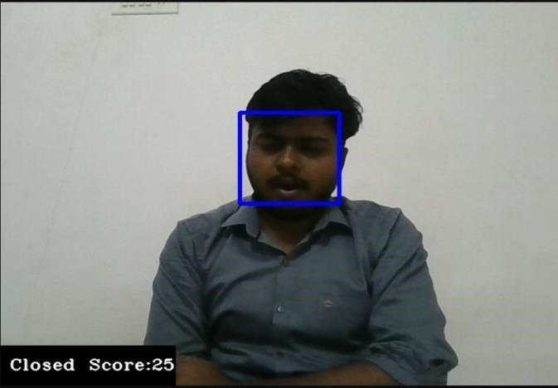

## Figure 4 Performance Evaluation Images

### 4.2. Standard Dataset Used Table 3 Standard Dataset Used

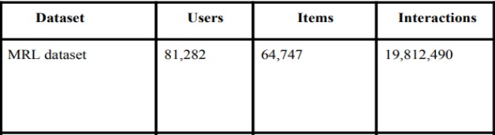

The dataset comprises infrared images captured under various lighting conditions and using different devices, encompassing both low and high resolutions in Figure 4. This dataset is appropriate for evaluating multiple features or trainable classifiers. To facilitate algorithm comparison, the images are categorized, making them suitable for training and testing classifiers. It contains 80 thousand images of 37 people consisting of 33 men and 4 women in Table 1,2&3.

### 4.3. Evaluation Parameters

Assessing the performance of a Drowsiness Detection and Alert System involves several key evaluation metrics:

**Accuracy:** This metric evaluates the accuracy of drowsiness detection by determining the proportion of accurately identified drowsy and awake states relative to the total sample size in Figure 5.

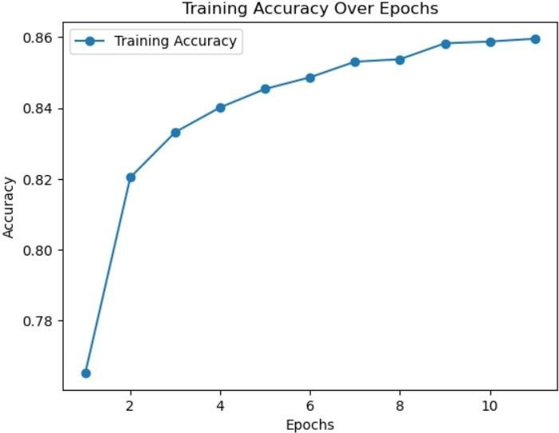

## Figure 5 Accuracy

**Precision:** Precision assesses the system's capacity to reduce false alarms by calculating the proportion of accurately identified drowsy instances among all positive predictions in Figure 6.

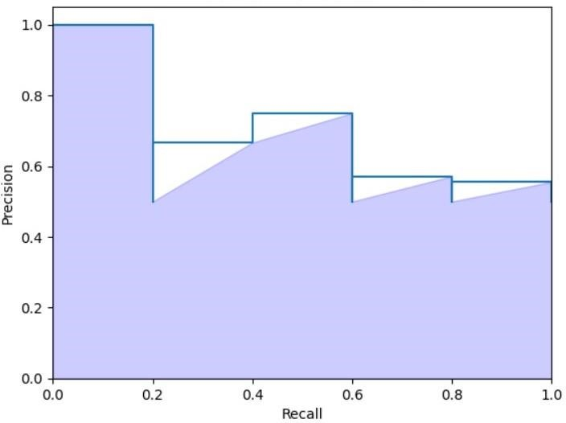

## Figure 6 Precision

**Recall (Sensitivity):** Recall, alternatively referred to as sensitivity or the true positive rate, evaluates the system's accuracy in detecting drowsy states by determining the proportion of true positives among all actual drowsy states.

**F1 Score:** The F1 score offers a well-rounded evaluation of the system's effectiveness by computing the harmonic mean of precision and recall. This approach accounts for both false positives and false negatives, providing a balanced perspective on performance in Figure 7.

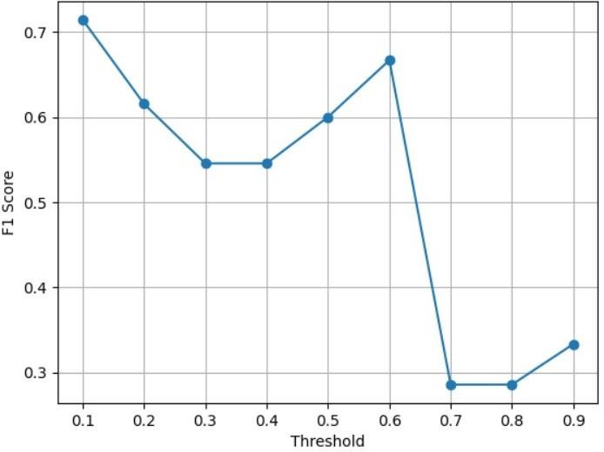

## Figure 7 F1 Score

**Confusion Matrix:** A confusion matrix acts as a thorough instrument, distinguishing between true positives, true negatives, false positives, and false negatives, thereby providing a detailed understanding of the system's effectiveness. By analyzing these components, it enhances understanding of the model's precision and identifies areas for enhancement, empowering informed decision-making across applications like machine learning and predictive analytics in Figure 8.

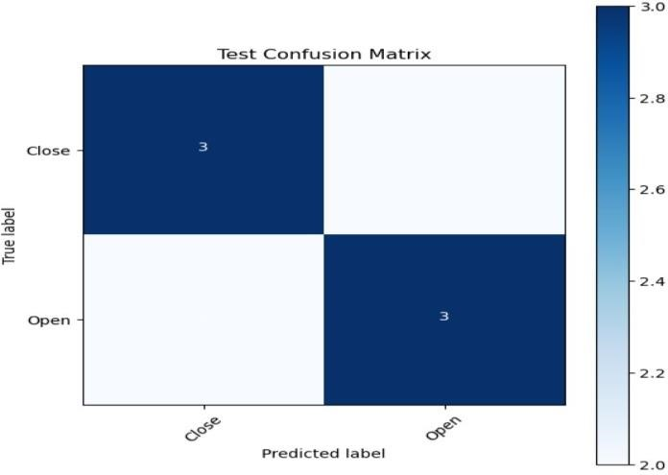

**Figure 8 Confusion Matrix**

# Conclusion

By combining the accessibility of Android devices with the advanced capabilities of deep Learning algorithms, drowsiness detection using infrared sensors has the potential to greatly improve the safety and productivity of individuals in their daily lives. One of the key features of our model is that it can detect drowsiness at night as well using Mobile cameras (infrared sensors). The system uses the MRL Eye Dataset, a collection of images of the driver’ eyes, to identify signs of drowsiness.

The EAR and MAR sensors monitor eye and mouth movements respectively and send an alert if detected drowsy on a mobile app to alert the driver. Through the analysis of these data streams, the system can detect the degree of drowsiness and notify the driver through either an alarm or vibration. Our drowsiness detection and alert system, trained with inception V3 and VGG19 models, marks a substantial advancement in improving road safety. Achieving an accuracy of 50% in inception V3 and 82% with the VGG19 model is a commendable feat, and we have implemented a robust backend using Flask to deploy and run these models on the web.

# Acknowledgement

We extend our gratitude to Professor Arpita Agarwal, our primary project mentor, for her invaluable guidance throughout the project. She not only assisted us in applying the knowledge gained throughout the semester but also facilitated our understanding of new concepts. We wish to extend our sincere appreciation to Professor Sharvari Govilkar, the Head of the Computer Engineering Department, for granting us the opportunity to undertake this major project. Through her support, we were able to delve into new concepts and their practical applications, enriching our learning experience.

# Reference

[1]. Ayush Goel 1, Jainav Sharma 2, Sumit Jindal 3, Rohit Sainthe i 4, Yash Garg 5 UG

Scholar “Driver Drowsiness Detection System” Computer Science & Engineering Meerut Institute of Engineering and

Technology, Meerut Meerut, India

|  |  |
| --- | --- |
|  |  |
| [2]. | Jaspreet Singh Bajaj 1, Naveen Kumar 1, Rajesh Kumar Kaushal, H. L. Gururaj 2, Francesco Flammini 3, “System and  Method for Driver Drowsiness Detection Using Behavioral and Sensor-Based  Physiological Measures” Chitkara University Institute of Engineering and Technology, Chitkara University, Punjab 140401, India |
| [3]. | Jagbeer Singh, Ritika Kanojia, Rishika Singh, Rishita Bansal, Sakshi Bansal  “Driver Drowsiness Detection System - An  Approach by Machine Learning Application” Computer Science and Engineering Dept, Meerut Institute of Engineering and Technology, Meerut, India |
| [4]. | Israt Jahan, K. M. Aslam Uddin, Saydul Akbar Murad, M. Saef Ullah Miah, Sultan Aljahdali and Anupam Kumar Bairagi, "4D: A Real-Time Driver Drowsiness Detection Using Deep Learning ", Department of  Information & Communication Engineering, Noakhali Science and Technology University, Noakhali 3814,  Bangladesh (2023) |
| [5]. | Yuhua Ma1, Ye Tao, Yuandan Gong, Wenhua Cui and Bo Wang,"Driver identification and fatigue detection algorithm based on deep learning “, School of Computer Science and Software Engineering, University of Science and Technology Liaoning, Anshan, China (2023) |
| [6]. | Ruilin Li b, Ruobin Gao c, Ponnuthurai Nagaratnam Suganthan,"A decompositionbased hybrid ensemble CNN framework for driver fatigue recognition", KINDI Center for Computing Research, College of Engineering, Qatar University, Doha, Qatar (2023) |
| [7]. | V. Uma Maheswari1, (Member, IEEE), Rajanikanth Aluvalu2, (Senior Member, IEEE), MVV Prasad Kantipudi3, (Senior |

|  |  |
| --- | --- |
|  | Member, IEEE), Krishna Keerthi  Chennam4, Ketan Kotecha3,5, and Jatinder kumar R. Saini6 “Driver Drowsiness Prediction Based on Multiple Aspects Using  Image Processing Techniques”,IEEE (2022) |
| [8]. | Anh-Cang Phan 1, Ngoc-Hoang-Quyen Nguyen 1, Thanh-Ngoan Trieu 2 and  Thuong-Cang Phan 3An “Efficient  Approach for Detecting Driver Drowsiness Based on Deep Learning”, Faculty of Information Technology, Vinh Long University of Technology Education, Vinh  Long 85110, Vietnam (2021) |
| [9]. | Md.Tanvir Ahammed Dipu,Syeda Sumbul Hossain,Yeasir Arafat, Fatama Binta Rafiq Real-time “Driver Drowsiness Detection using Deep Learning International Journal of Advanced Computer Science and  Applications”,Bangladesh(2021) |

[10]. Hrithik Haritash, India Sushma Yadav,

Rajat Rathi “DRIVER DROWSINESS DETECTION SYSTEM”, IIMT College of Engineering, Greater Noida,202310, India (2022)

[11]. Elena Magán, M. Paz Sesmero, Juan Manuel Alonso-Weber and Araceli Sanchis Driver “Drowsiness Detection by Applying

Deep Learning Techniques to Sequences of

Images”, Computer Science and Engineering Department, Universidad Carlos III de Madrid, 28911 Leganés, Spain (2022)

[12]. Tarig Faisal, Isaias Tesfu.Ghebrehiwet ,Araya.Mohammed Yassin “Systematic development of Real-Time Driver Drowsiness Detection System using Deep

Learning”,Higher College of Technology United Arab Emirates (2021)

[13]. B. Rajkumarsingha and D. Totahb “Drowsiness Detection using Android Application and Mobile Vision Face API”, India (2021)

[14]. Rohith Chinthalachervu, Immaneni Teja, M. Ajay Kumar, N. Sai Harshith, T. Santosh Kumar Driver Drowsiness Detection and Monitoring System using Machine Learning Department of ECE, GRIET, Hyderabad, Telangana, India (2022).

[15]. Vijayvargiya, Vishal, et al. "Driver Drowsiness Detection System." International Research Journal of Engineering and Technology, vol. 8, no. 5, 2021, pp. 3266-3271.